**Reloading A Scene**

This will show you how to restart a level or scene within Unity.

1. **Making a button**

Right-Click in the Hierarchy, Select “UI” and pick Button.

Edit the Text so it says “Test” instead of “Button”.

1. **Making a Script**

Create a script and call it “LoadCurrent”. And Open the Script.

Before anything, we need to add “using UnityEngine.SceneManagement” just below “using UnityEngine;”

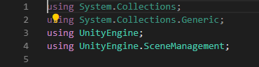

Next create a new “public void” and name it “LoadCurrentScene”



Within this new void, we are going to type in only one line of code.

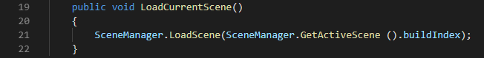

Thats call the coding done, move back to unity.

1. **Linking the Button**

Drag the Script on the “Button”.

Then click on the “Button” in the Hierarchy and scroll down the “inspector” until you find the “On-Click” function.

Click on the small plus icon and drag the “Button” from the Hierarchy into the box just below “Runtime”.

Click where is says “No Function” and Select “LoadCurrent” and then select “LoadCurrentScene”.